Practical - 8
Practical Title: MySQL Schema Design, ER Model, PDO Connectivity, and Prepared Statements

Problem Definition: Design the database for StudentHub with students, events and registrations. Create PHP database connection using MYSQL statements.

Theory

Is the schema normalized properly?
Answer: Yes, the StudentHub database is normalized by separating the data into three tables: students, events, and registrations. The students table stores student information, the events table stores event details. This reduces data redundancy, avoids unnecessary duplication, and helps maintain data consistency. .

Are primary keys and foreign keys correctly defined?
Answer:Yes, primary keys and foreign keys are used to maintain data integrity. The student_id in the students table and event_id in the events table uniquely identify each record. The registration_id in the registrations table uniquely identifies each registration. Foreign keys in the registrations table reference student_id and event_id, ensuring that registrations are associated with existing students and events.

3. Is the database connection handled securely?
Answer: Write your answer in your own words. Do not copy and paste content directly from AI tools. At the end of your answer, provide the website(s) or reference link(s) you used for research.

Implementation
Database connection using PHP PDO (db.php)
<?php
$host = "localhost";
$dbname = "studenthub";
$username = "root";
$password = "";
try {
$pdo = new PDO(
"mysql:host=$host;dbname=$dbname;charset=utf8mb4",
$username,
$password
);
$pdo->setAttribute(
PDO::ATTR_ERRMODE,
PDO::ERRMODE_EXCEPTION
);
echo "Database connected successfully!";
} catch (PDOException $e) {
die("Database connection failed.");
}
?>

Evidence of Work (Screenshots)
Figure 1.1 Database in phpMyAdmin
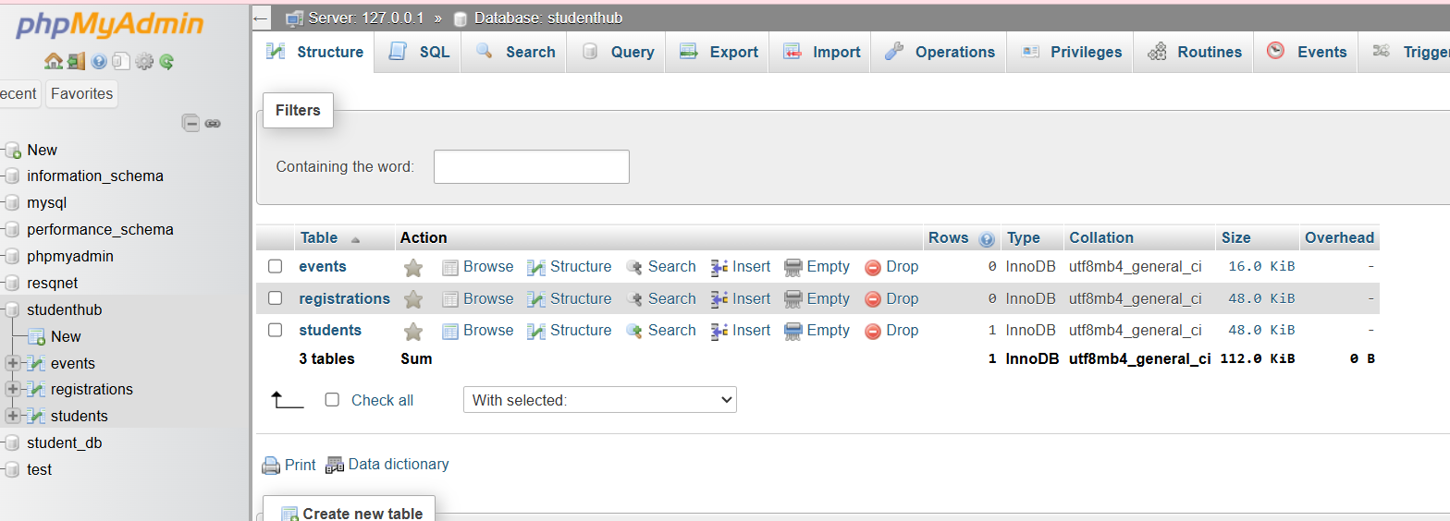
Description: Students, events and registration table

Figure 1.2 Testing Connection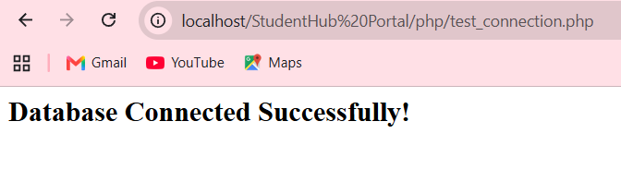
Description: Successful message display

Figure 1.3 ER diagram

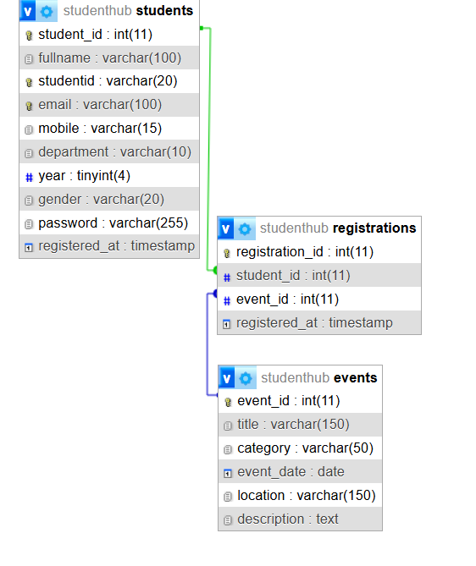
Description: ER diagram showing tables, columns and relations

GitHub Repository Link:
https://github.com/heerce27/StudentHub-Portal.git

Challenges Faced:

Defining primary keys and foreign keys correctly to maintain data integrity.

Learning Outcomes:

Learned how to design a MySQL database schema and create tables with appropriate constraints.

Understood database normalization and the importance of primary keys and foreign keys.

Learned to connect PHP with MySQL using PDO.

Faculty Remarks:

